## ****Honey (Shehad)****

**Uses:**  
• Antibacterial  
• Anti-inflammatory  
• Wound healing & minimizes scarring  
• Antioxidant effects  
• Helps in respiratory, gastrointestinal & skin conditions  
• Stimulates digestion and regulates gastric acidity

**Dose:**  
• Cough: 2.5 mL before bedtime (children >1 year)  
• Minor cuts/burns: apply raw honey directly + gauze  
• Sedation: 1 tsp honey in warm milk before bed  
• Constipation: 1 tbsp raw honey in warm water, morning

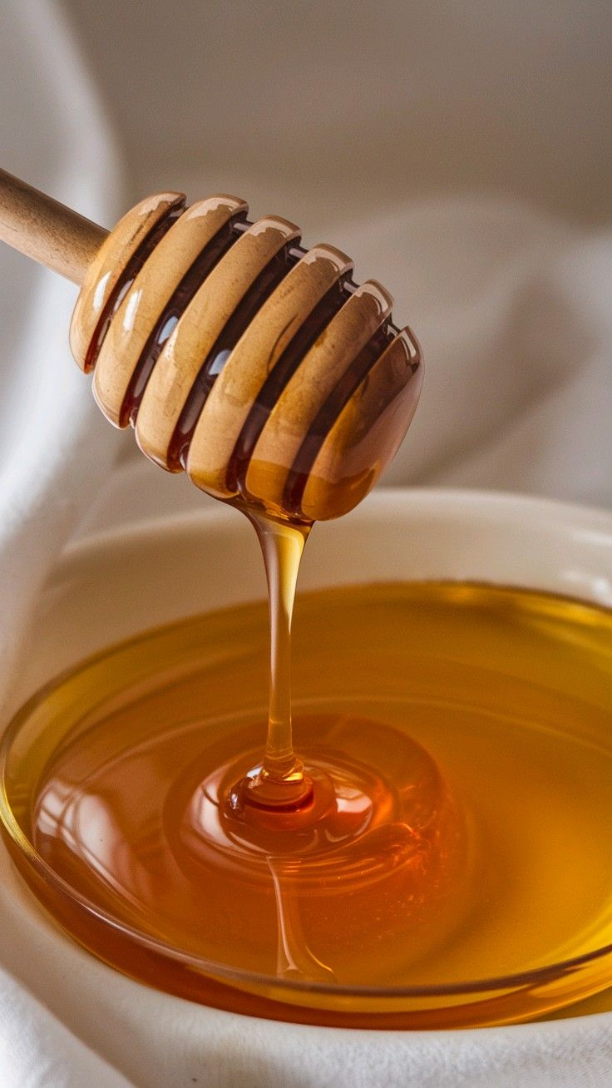**Side Effects:**  
• Unsafe for infants under 1 year (infant botulism)  
• Wheezing, nausea, vomiting, dizziness possible  
• May cause irregular heartbeat in sensitive people  
• Can affect blood sugar  
• Stinging after topical application

**ISLAMIC REFERENCES:**

Al-Bukhari narrated that the Prophet said:

"There is cure in three substances, a drink of honey, a slash with a knife used for cupping and cauterizing by fire. I forbid my nation from cauterizing by fire "

* it washes away the harmful substances that may have collected in the veins and the intestines.
* It is of great value for the elderly, and those suffering from phlegm and cold moods or conditions like chills.
* Honey is nutritious, softens the bowel movement and is a good preserving agent.
* Taking honey mixed with water helps against the bite of a rabid dog
* The Prophet used to drink some honey mixed with water on an empty stomach.
* A Hadith [narrated by ibn Majah and others] stated that the Prophet is said:   
  "Make use of the two cures: honey and the Qur'an."

## ****Almond (Badam)****

**Uses:**  
• Lowers cardiovascular disease risk (improves cholesterol)  
• Improves lipid profiles, reduces cardiometabolic risks  
• Beneficial in hyperlipidemia  
• Meets nutrient requirements (Vitamin E, Mg, K)  
• Supports diabetes management (better insulin sensitivity)  
• Antioxidant properties

**Dose:**  
• Heart health: 42.5 g (~35 almonds) daily  
• Lipid profile: 43 g/day  
• Hyperlipidemia: 50–100 g/day  
• Nutrient supply: 28 g provides Vitamin E, Mg, K  
• Diabetes management: 60 g/day  
• Antioxidant: 50–84 g/day

**Side Effects:**  
• May cause allergic reactions  
• Long-term use may affect insulin sensitivity

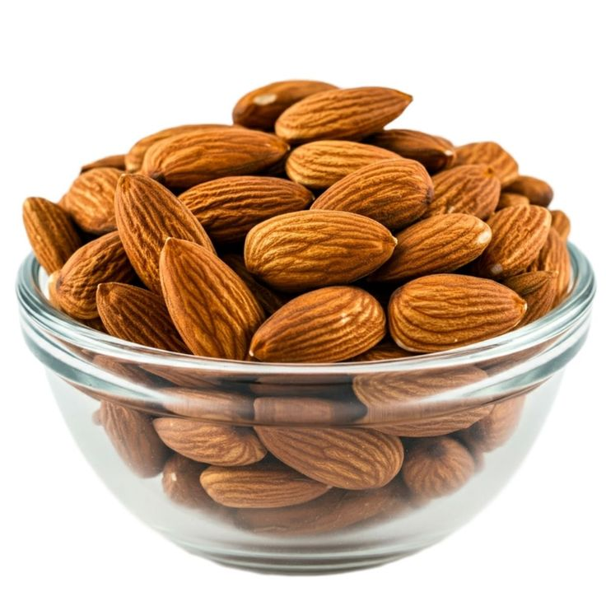

**Ginger (Adrak)**

**Uses:**  
• Relieves nausea  
• Reduces inflammation  
• Aids digestion  
• Prevents heart disease  
• Relieves arthritis pain

**Dose:**  
• Pregnancy nausea: 250 mg daily for 4 days  
• Post-surgery nausea: 0.5–1 g  
• Coronary artery disease: 10 g reduces platelet aggregation

**Side Effects:**  
• GI issues: mild diarrhea, heartburn, irritation at high doses (6 g)  
• Allergic reactions possible (ginger dust inhalation)

**ISLAMIC REFERENCES:**

* Ginger helps the digestion process, softens the stomach mildly
* helps open the clogs of the liver
* Ginger decomposes the thick gases accumulating in the intestines
* When one takes some ginger along with two measures of sugar and some hot water, it will work as a laxative and will rid the body of harmful excrements.
* dries the phlegm that prevails in the body

increases the memory power.

## 

## ****Lemon (Nimbu)****

**Uses:**  
• Rich in Vitamin C  
• Anticancer properties  
• Antibacterial activity  
• Protects gastric lining  
• Supports antiulcer effects  
• Prevents scurvy

**Dose:**  
• Antibacterial: 900 mg/mL lemon juice  
• Vitamin C: 90 mg/day (men), 75 mg/day (women)  
• Prevention of scurvy: 10 mg/day

**Side Effects:**  
• Regular lemon water can erode tooth enamel  
• May cause dentin hypersensitivity (tooth sensitivity)

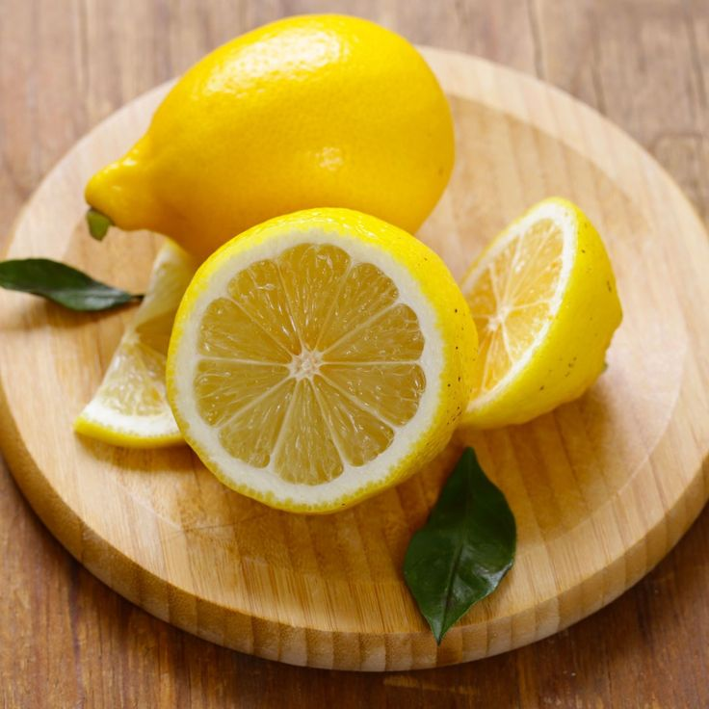

##### **Walnut (Akhrot)**

**Uses:**  
• Provides essential nutrition  
• Strong antioxidant  
• Lowers risk of cancer, diabetes, heart & brain disorders  
• Relieves pain  
• Anti-inflammatory effects

**Dose:**  
• Diets with 2–6% walnuts reverse age-related decline  
• 110–440 mg/kg boosts immunity

**Side Effects:**  
• Mutagenic properties in excess  
• Strong laxative effect at high doses  
• Can trigger allergies & anaphylaxis  
• May cause stomach irritation  
• Black walnuts reduce absorption of some medicines (wait 1–2 hrs)

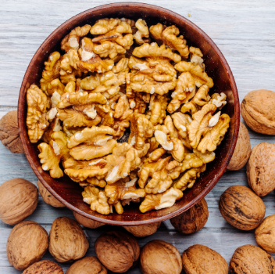

**Peppermint oil (Roghan-e-podina)**

**Uses:**

Migraine, Headache, Irritable bowel syndrome, neuralgia, dyspepsia

**Dosage**

* The dosage range IBS is 0.2 to 0.4 mL of peppermint oil taken three times daily.
* The combination use in dyspepsia is 90 mg of peppermint oil + 50 mg of caraway oil
* 5ml peppermint oil for the treatment of migraine

**Precaution:**

Should not be used in infants or very young children, pregnant or lactating women

**Adverse effects**

Perianal burning, blurred vision, nausea, and vomiting and rarely interstitia

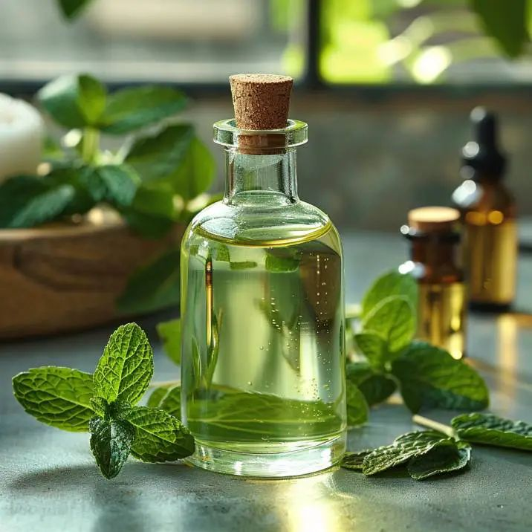

**Turmeric (Haldi)**

**Use**:

pain and postoperative fatigue after surgery and has an anti-inflammatory effect

**Dose:**

For fatigue take 500 mg capsule once every 6 hours for 3 weeks

Anti-inflammatory effect: 400 mg of curcumin

The Food and Drug Administration (FDA) considers turmeric safe in doses from 4,000-8,000 milligrams a day.

**Adverse effects:**

Dermatitis, neurotoxic potential of curcumol, inhibition of sperm motility and function causing reduction in fertility

